Project Diagram
On
Real Estate Management System
By
www.programmer2programmer.net www.readymadeproject.com ajprofessionals@gmail.com

INTRODUCTION
Study of Existing System
The system consist of two modules
- Administrator and
- Customer
The system was supposed to provide the following facilities
- Searching for property
- Viewing property information
- Viewing seller information
- Booking property
- Good user interface
Limitations of Existing System
- Searching facility for property was poor
- Difficult to manage the property and owner information
- The system does not keep the proper records of customers
- The system interface was not user friendly
- Difficult to generate report
- Time consuming

PROPOSED SYSTEM
Scope of Proposed System
➢Consist of three modules
➢Administrator
➢Agent
➢Customer
➢Provides property information online
➢Provides online property booking
➢Useful for property buyers
➢Useful for property managers

Objectives of Proposed System
➢Easy to operate.
➢Easy to search property.
➢Proper management of property.
➢It should be easy to update property information.
➢Easy to add/update seller/agent/customer information.
➢Reduces amount of work.

OPERATING ENVIRONMENT
HARDWARE REQUIREMENTS
➢ Processor | : | i7
➢ RAM | : | 4 GB or Higher
➢ Hard Disk | : | 80 GB
➢ Input Device | : | Keyboard, Mouse
➢ Output Device | : | Monitor
SOFTWARE REQUIREMENTS
➢ Operating System : | Windows 10
➢ Front End : | Java Server Pages (JSP)
➢ Back End : | Servlets, JavaBeans and JDBC
➢ Database : | My SQL 6.5 or Higher
➢ Web Server : | Apache Tomcat 6.0
➢ Other Technology : | Java Script, HTML and CSS

DIAGRAMS
CLASS DIAGRAM
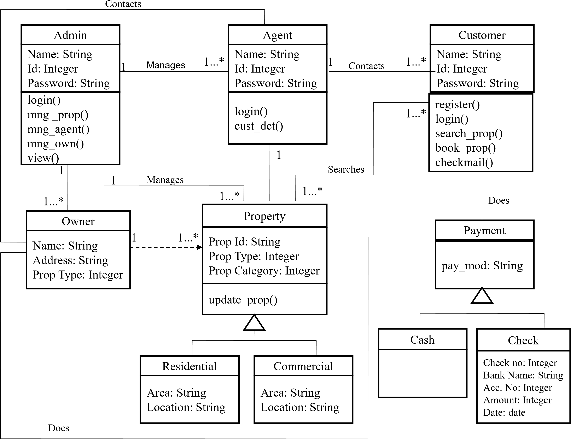
Module Hierarchy Diagram:
Real Estate Management System
Customer
Administrator
Agent
View Report
Manage property
details
Manage owner
details
Manage Agent
Property
View customer
details
Login Module
Login Module
Property Search
Module
Login Module
View customer
details
Contact
Customer
Registration
Module
Book Property
Contact Owner
Registration
Module
UML Diagram For System
Search Property
Contact Agent
Manage Agent
property
Book Property
Contact Customer
Manage Owner
Customer
Agent
Admin
Manage Property
Reports
Use Case Diagram For Customer
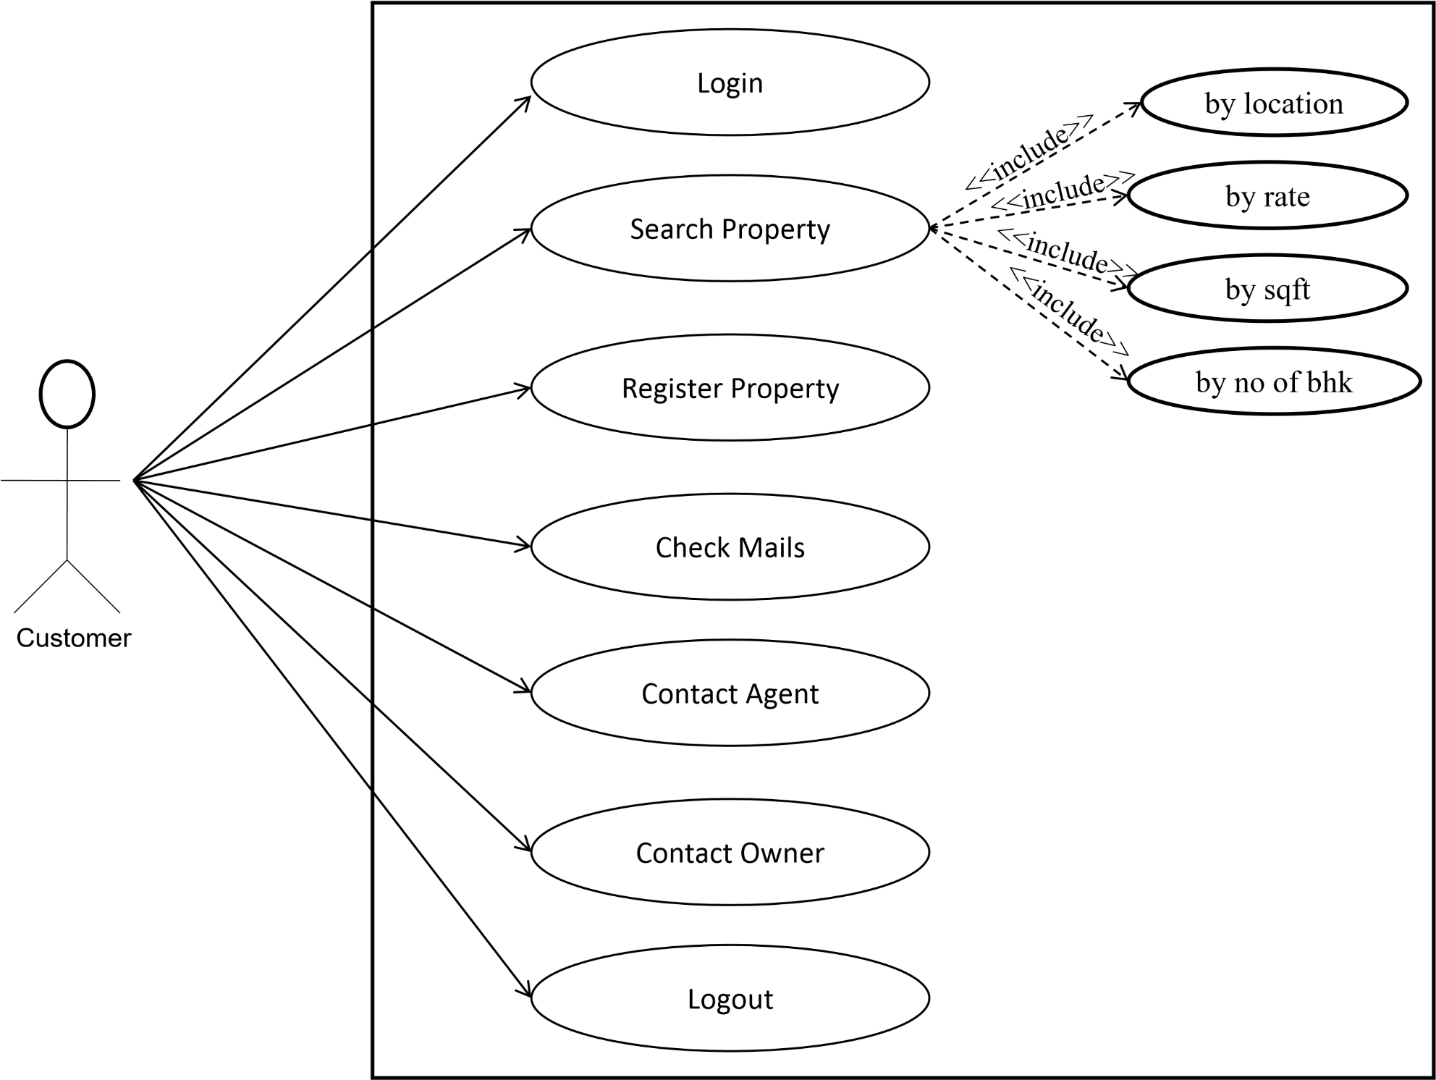
Use Case Diagram For Agent
Agent
Send Mails
Login
Check Customer
Information
Logout
Check Mails
Contact Owner
Contact Customer
Send Mail
Use Case Diagram For Administrator
Login
Manages Property
Information
Send Mail
Manages Owner
Information
Logout
Check Mails
View Reports
View Registered
Property
Manages Agent
Property
Administrator
add
update
delete
Activity Diagram For Customer
valid
no
yes
Search Property
Register
By Category
By Location
By Rate
valid
Logout
Login
Check Mails
invalid
Book Property
Verify
Book
Property
Registered
yes
no
Activity Diagram For Agent
invalid
valid
Verify
Login
Check Customer Details
Logout
Send Mail
Check Mails
Activity Diagram For Administrator
Login
Manage property
View Customer
Details
Send Mail
verify
View Registered
property
Manage Agent
Manage Owner
Information
View Reports
By Category
By Rate
invalid
By Location
Logout
Sequence Diagram For Customer
Customer |  | Web Browser |  | Web Server |  | Database
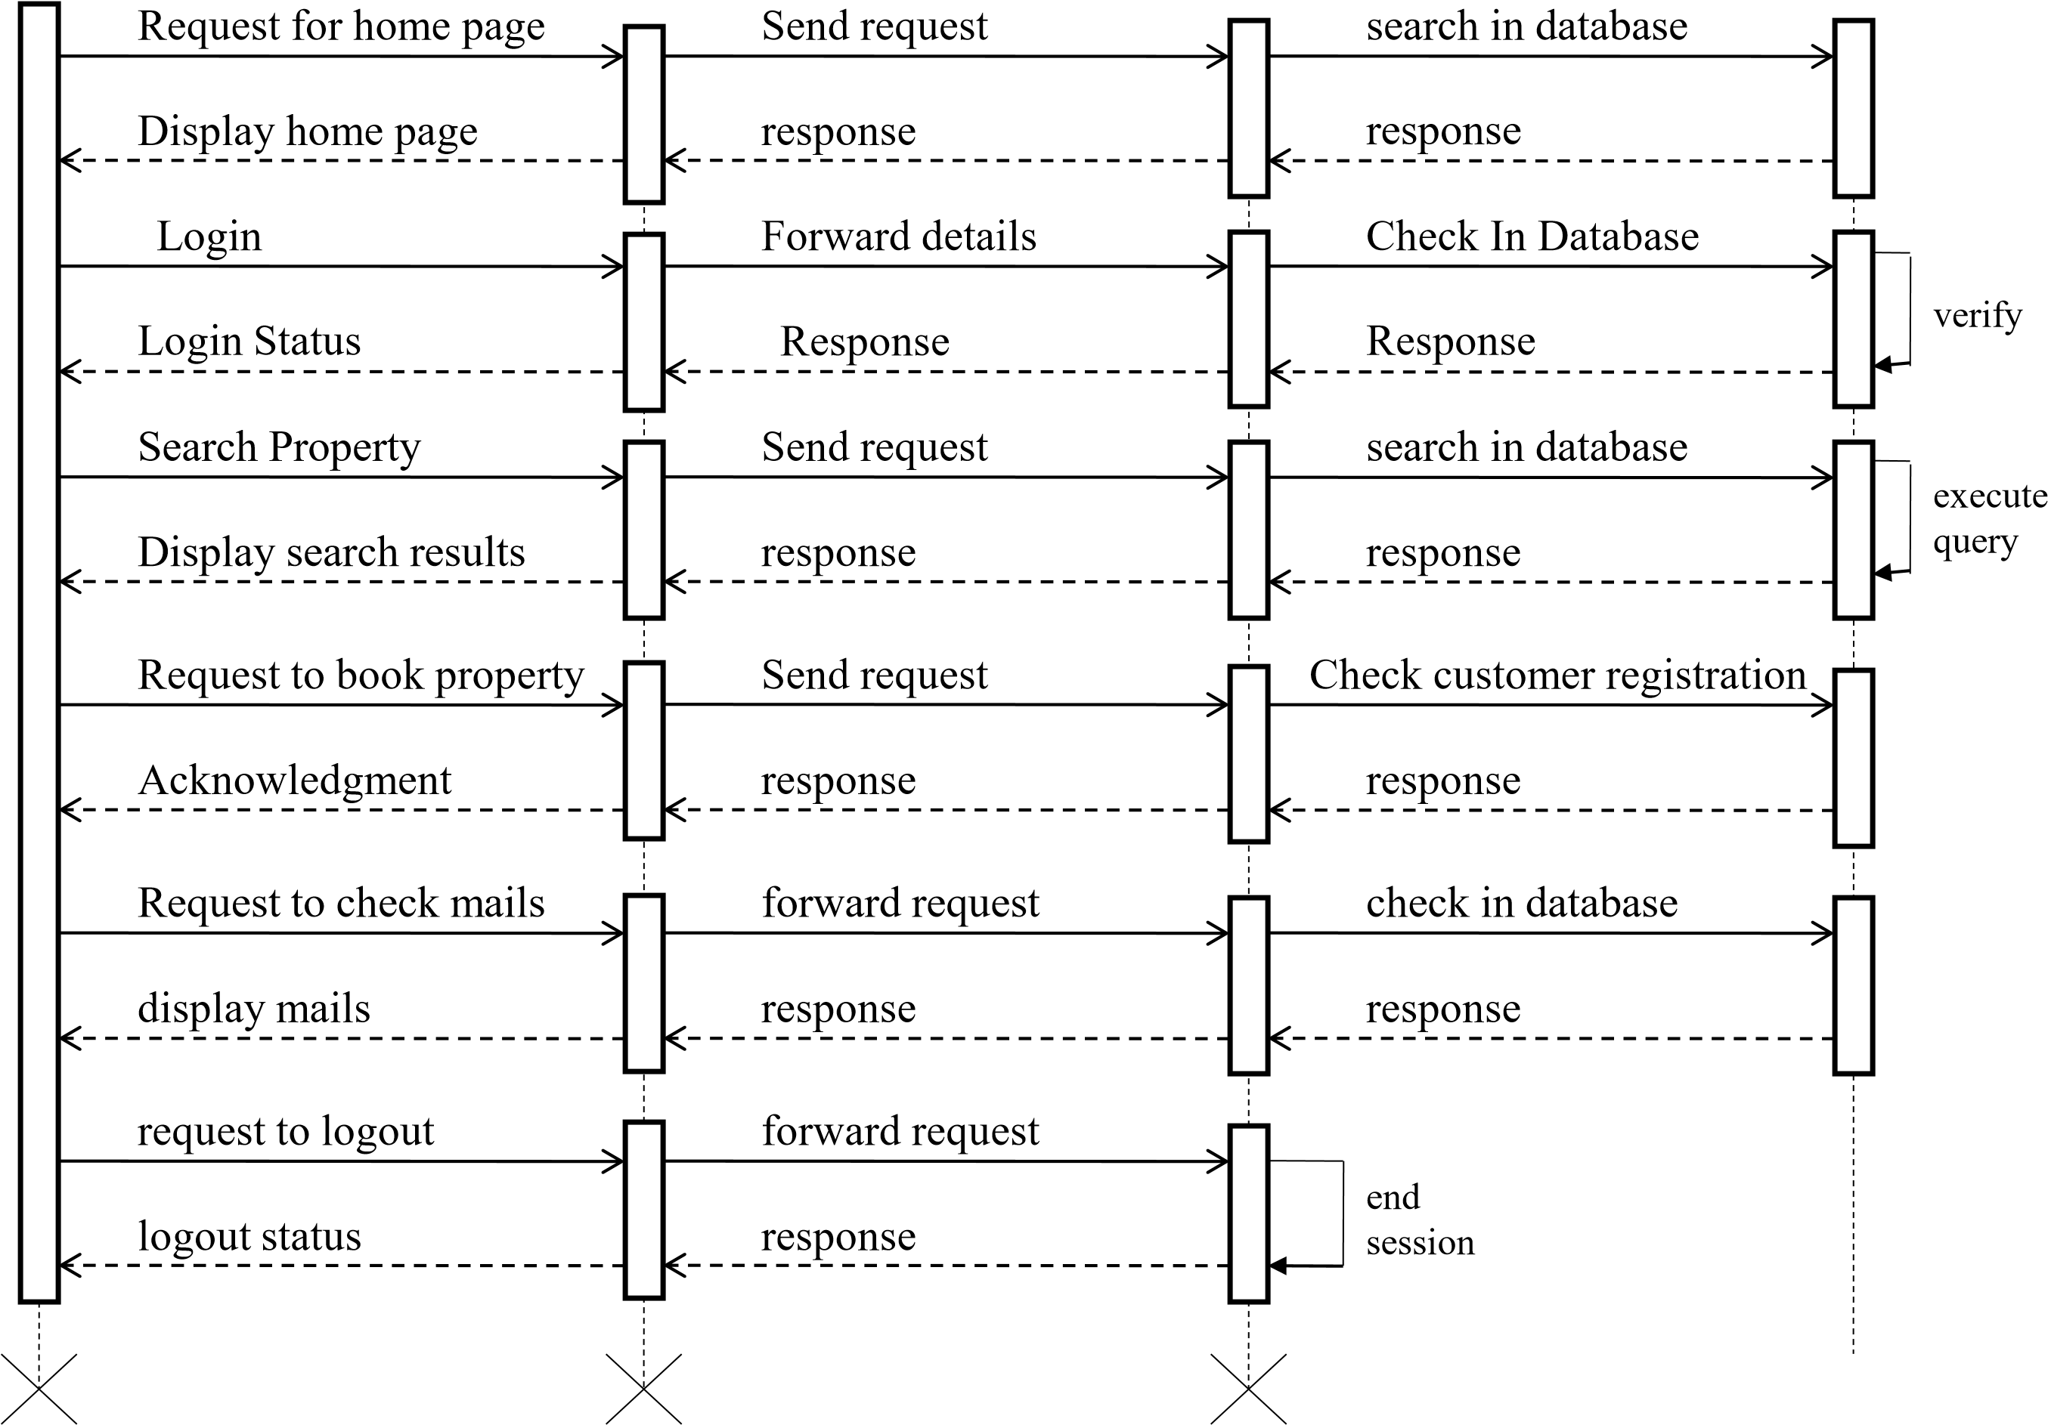
Sequence Diagram For Agent
Agent |  | Web Browser |  | Web Server |  | Database
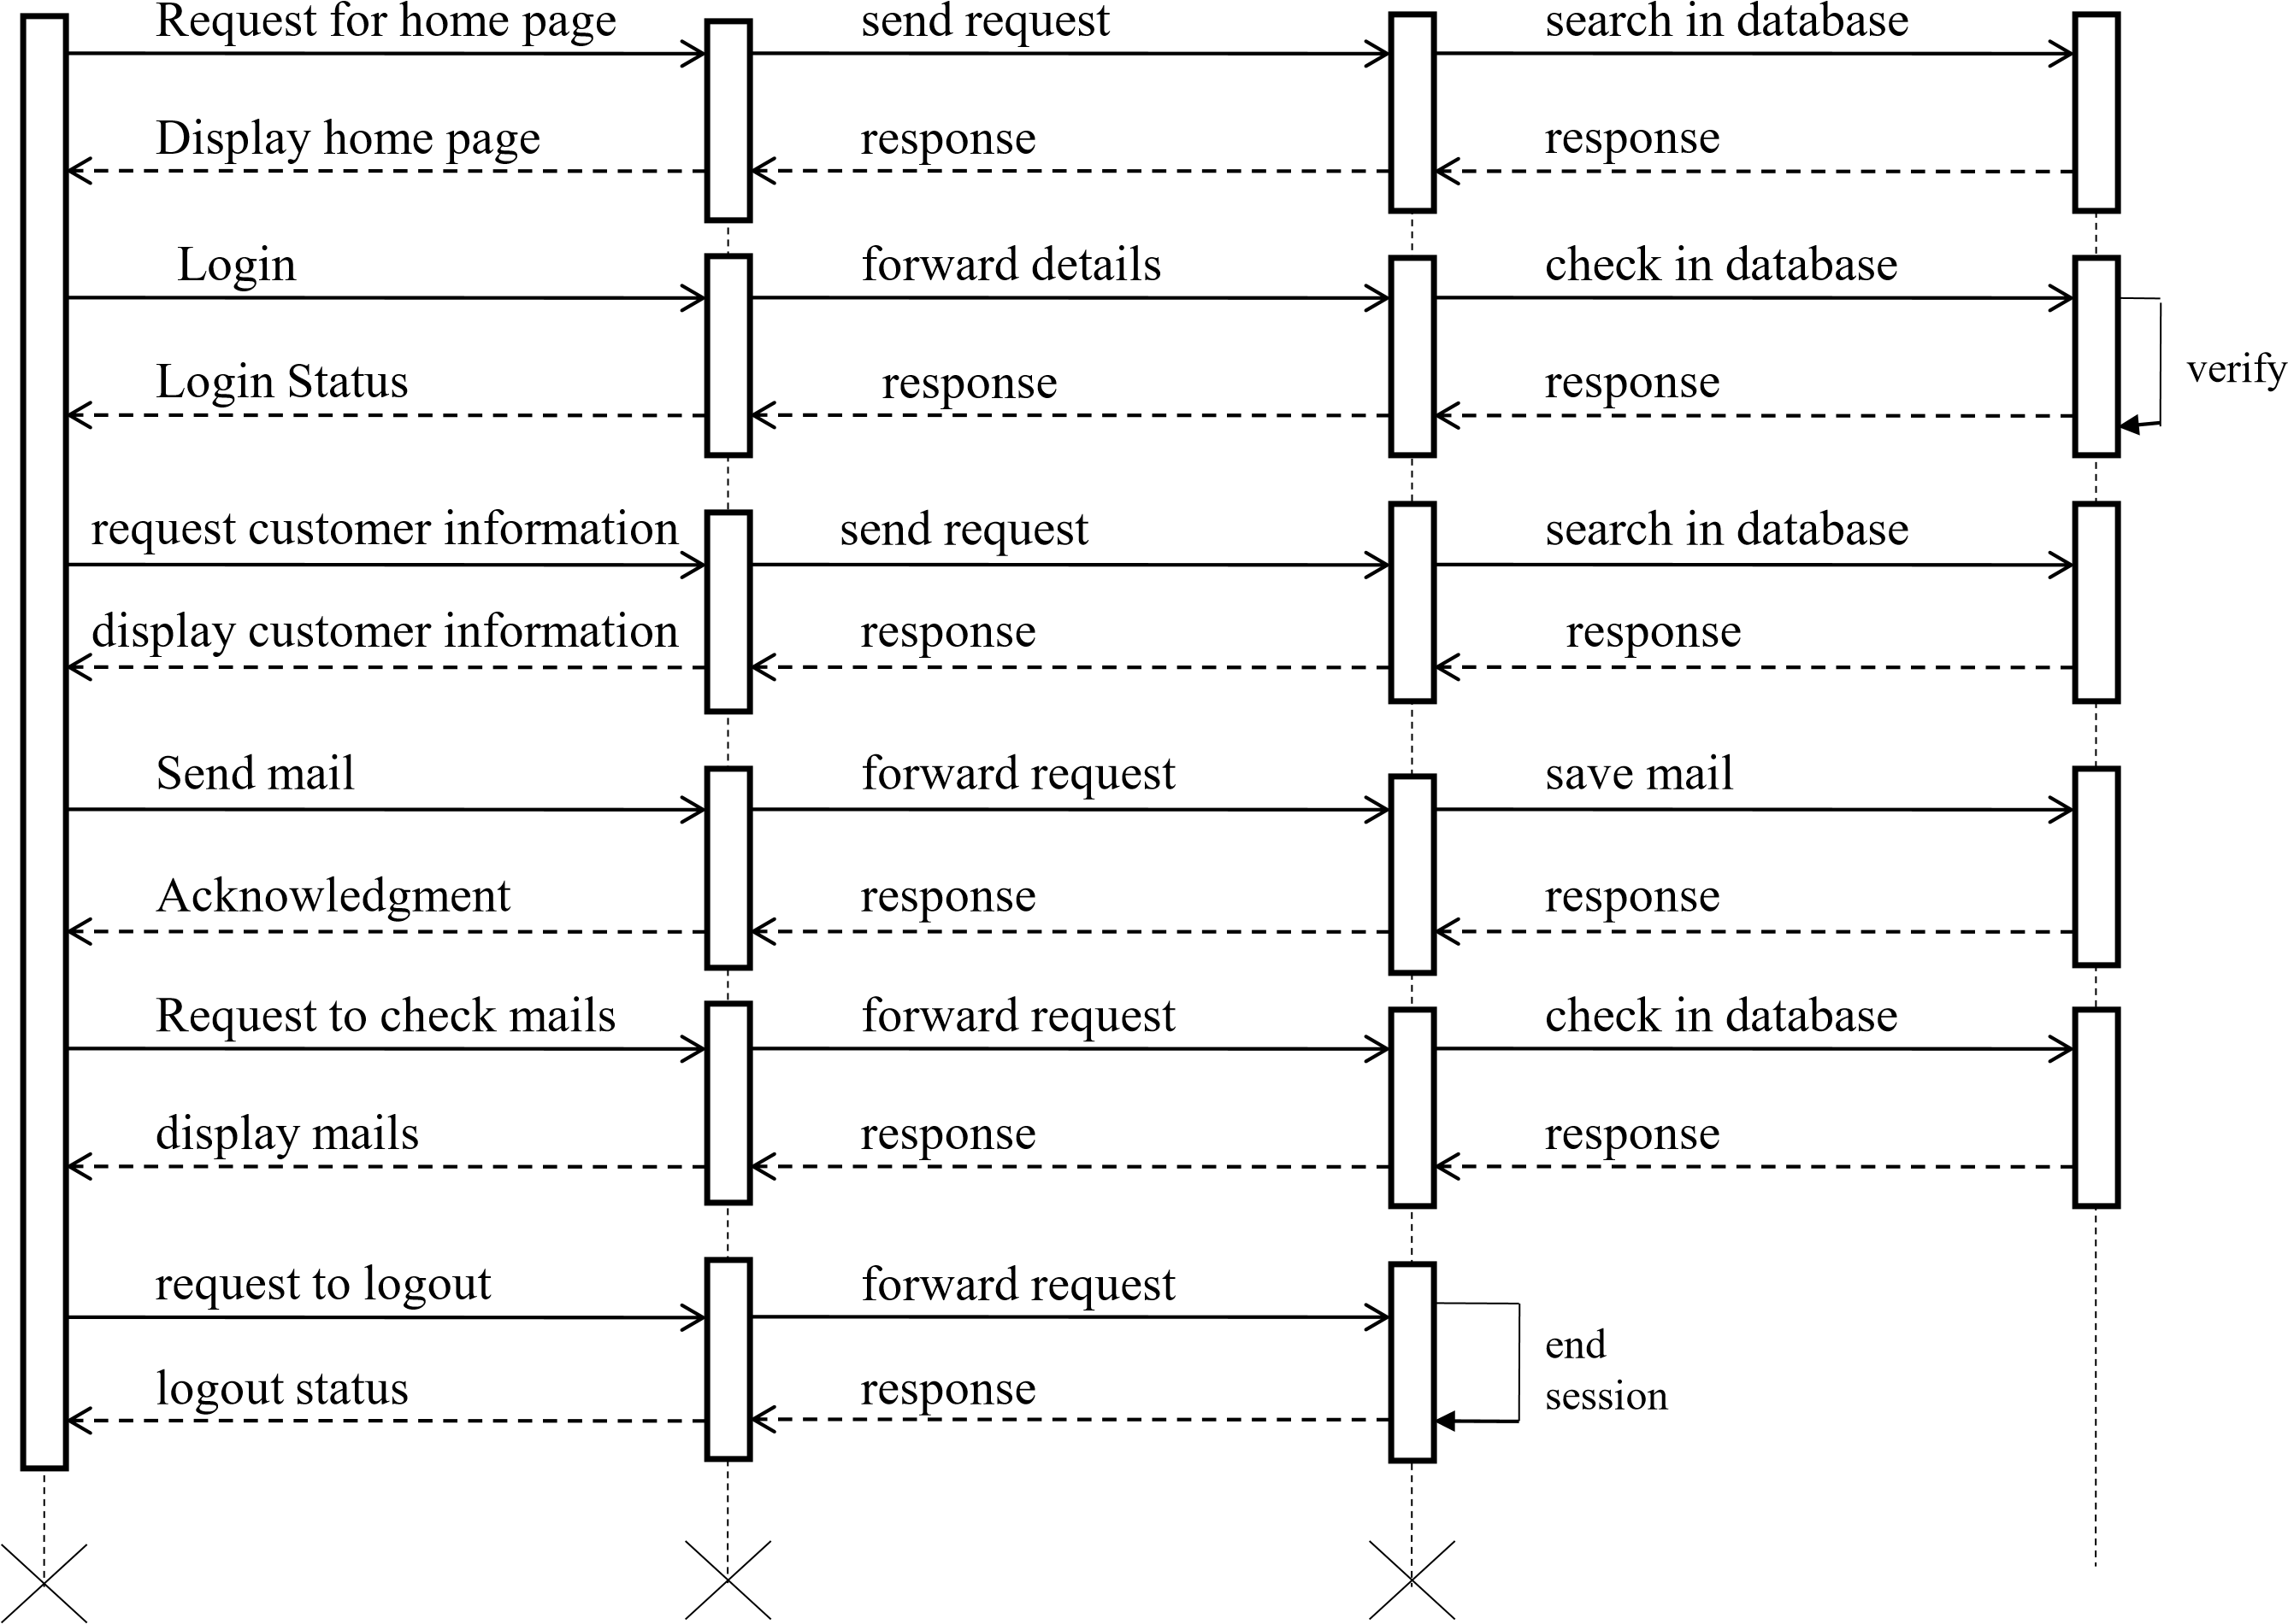
Sequence Diagram For Administrator
Admin |  | Web Browser |  | Web Server |  | Database
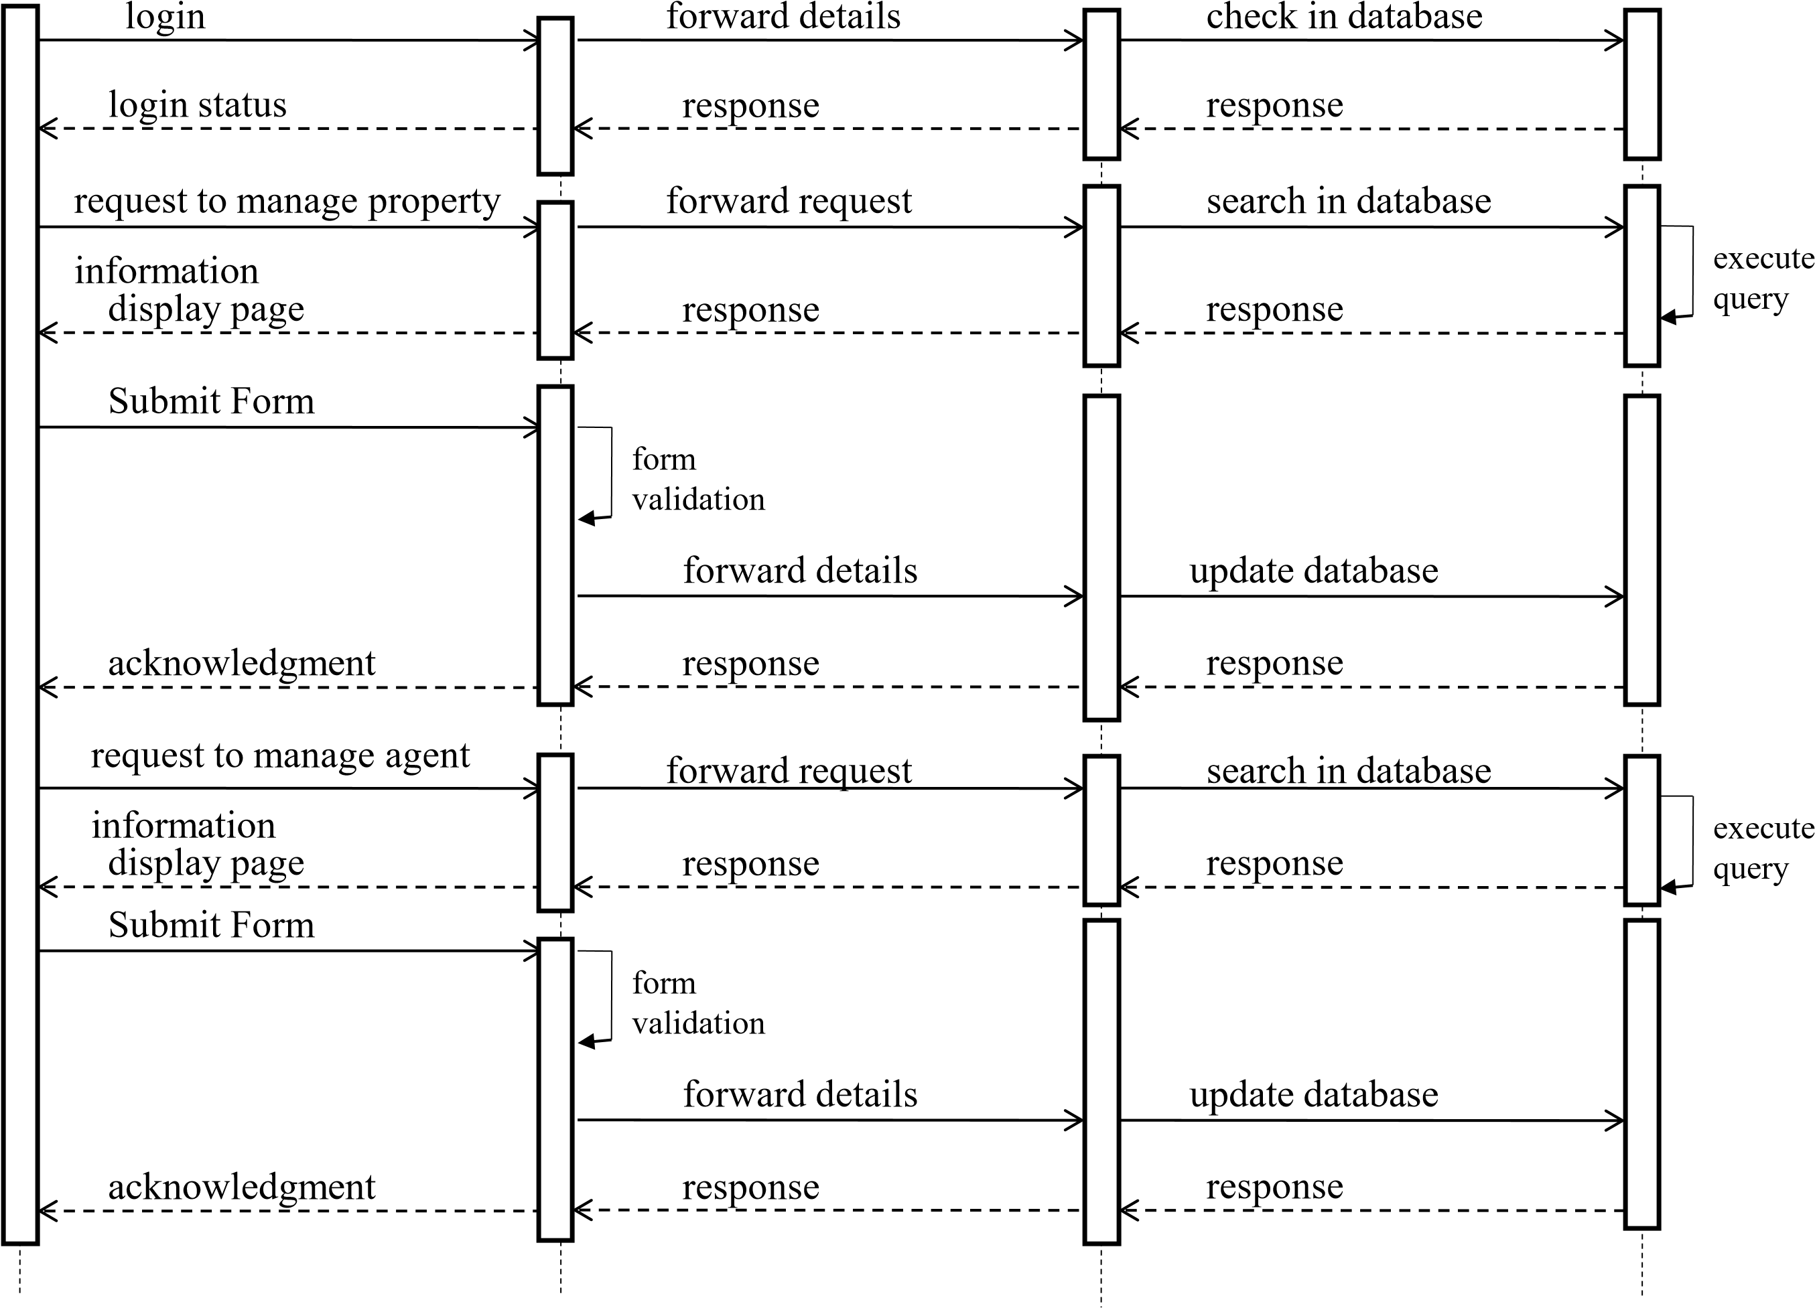
Sequence Diagram For Administrator(continue)
Admin |  | Web Browser |  | Web Server |  | Database
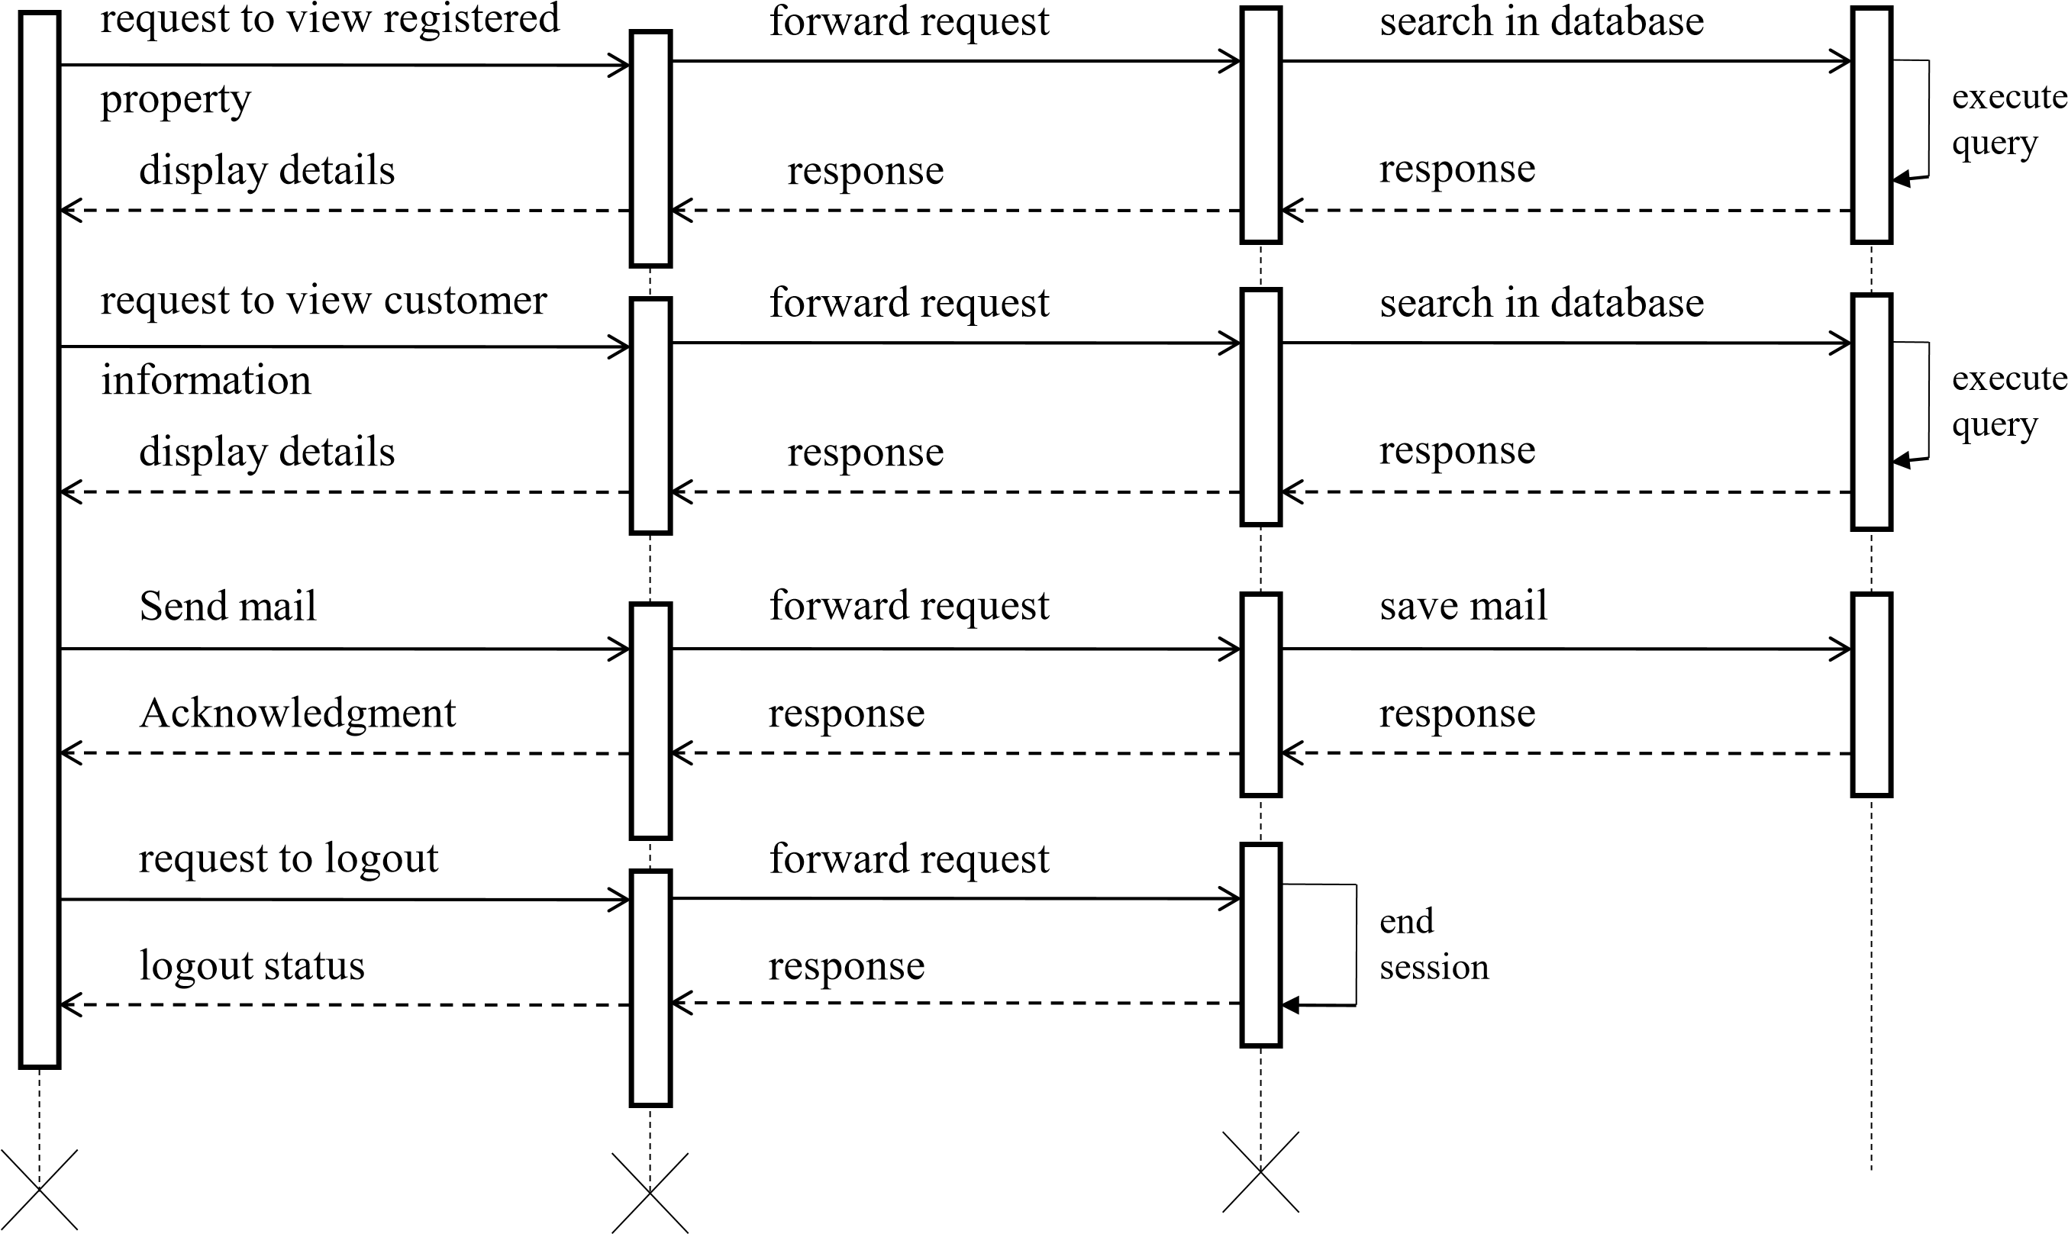
Component Diagram:
Client
Web Browser
Database
Application
Program
Web Server
Request to
Request to
Request to
Request to
Deployment Diagram:
User
Interface
Application
Interface
Database
Communicates
Application Server
User PC
Database Server

TABLE DESIGN
Table for Login
Field Name | Data Type | Width | Constraints
logintype_id | Integer | 2 | Primary Key
logintype | Varchar | 20 | Not Null
Table For State
Field Name | Data Type | Width | Constraints
state_id | Integer | 4 | Primary Key
state_name | Varchar | 45 | Not Null
Table For City
Field Name | Data Type | Width | Constraints
city_id | Integer | 4 | Primary Key
city_name | Varchar | 45 | Not Null
state_id | Integer | 4 | Foreign key
Table For Area
Field Name | Data Type | Width | Constraints
area_id | Integer | 4 | Primary Key
area_name | Varchar | 45 | Not Null
city_id | Integer | 4 | Foreign Key
state_id | Integer | 4 | Foreign Key
Table For Property Category
Field Name | Data Type | Width | Constraints
prcategory_id | Integer | 4 | Primary Key
prcategory_name | Varchar | 45 | Not Null
Table For Property Type
Field Name | Data Type | Width | Constraints
prtype_id | Integer | 4 | Primary Key
prtype_name | Varchar | 45 | Not Null
prcategory_id | Integer | 4 | Foreign key
Table for Property Details:
Field Name | Data Type | Width | Constraints
pr_id | Integer | 10 | Primary Key
owner_id | Integer | 4 | Foreign Key
agent_id | Integer | 4 | Foreign Key
cust_id | Integer | 4 | Foreign Key
pr_date | Datetime | -- | Not Null
state_id | Integer | 45 | Foreign Key
city_id | Integer | 45 | Foreign Key
area_id | Integer | 45 | Foreign Key
prcategory_id | Integer | 2 | Foreign Key
prtype_id | Integer | 45 | Foreign Key
pr_area | Integer | 5 | Not Null
rate_per_sqft | Integer | 4 | Not Null
pr_rate | Integer | 10 | Not Null
no_bhk | Integer | 4 | May null
status | Boolean | -- | Not Null
Table For Owner Details
Field Name | Data Type | Width | Constraints
owner_id | Integer | 4 | Primary Key
owner_pr_id | Integer | 45 | Foreign Key
agent_id | Integer | 4 | Foreign Key
f_name | Varchar | 45 | Not Null
l_name | Varchar | 45 | Not Null
gender | Boolean | -- | Not Null
address | Varchar | 45 | Not Null
mobile_no | Integer | 10 | Not Null
email_id | Integer | 4 | Not Null
pay_id | Integer | 4 | Not Null
Table For Owner-Property Details:
Field Name | Data Type | Width | Constraints
owner_pr_id | Integer | 4 | Primary Key
owner_id | Integer | 4 | Foreign Key
pr_id | Integer | 4 | Foreign Key
Table For Customer Registration:
Field Name | Data Type | Width | Constraints
cust_id | Integer | 4 | Primary Key
logintype_id | Integer | 2 | Foreign Key
agent_id | Integer | 4 | Foreign Key
cust_pr_id | Integer | 4 | Foreign Key
cr_date | Datetime | -- | Not Null
f_name | Varchar | 45 | Not Null
l_name | Varchar | 45 | Not Null
sex | Boolean | -- | Not Null
address | Varchar | 45 | Not Null
mobile_no | Integer | 10 | Not Null
date_of_birth | Datetime | -- | Not Null
email_id | Varchar | 45 | Not Null
user_name | Varchar | 20 | Not Null
password | Varchar | 20 | Not Null
con_password | Varchar | 20 | Not Null
cust_email_id | Varchar | 4 | Foreign Key
Table For Customer-Property Details:
Field Name | Data Type | Width | Constraints
cust_pr_id | Integer | 4 | Primary Key
cust_id | Integer | 4 | Foreign Key
pr_id | Integer | 4 | Foreign Key
Table For Agent Registration:
Field Name | Data Type | Width | Constraints
agent_id | Integer | 4 | Primary Key
logintype_id | Integer | 2 | Foreign Key
agent_owner_id | Integer | 4 | Foreign key
agent_cust_id | Integer | 4 | Foreign Key
a_date | Datetime | -- | Not Null
f_name | Varchar | 45 | Not Null
l_name | Varchar | 45 | Not Null
sex | Boolean | -- | Not Null
address | Varchar | 45 | Not Null
mobile_no | Integer | 10 | Not Null
email_id | Varchar | 45 | Not Null
user_name | Varchar | 20 | Not Null
password | Varchar | 20 | Not Null
con_password | Varchar | 20 | Not Null
pay_id | Integer | 4 | Not Null
Table For Agent-Owner Details:
Field Name | Data Type | Width | Constraints
agent_owner_id | Integer | 4 | Primary Key
agent_id | Integer | 4 | Foreign Key
owner_id | Integer | 4 | Foreign Key
Table For Agent-Customer Details:
Field Name | Data Type | Width | Constraints
agent_owner_id | Integer | 4 | Primary Key
agent_id | Integer | 4 | Foreign Key
cust_id | Integer | 4 | Foreign Key
Table For Customer Email Details
Field Name | Data Type | Width | Constraints
cust_email_id | Integer | 4 | Primary Key
cust_id | Integer | 4 | Foreign Key
e_date | Datetime | -- | Not Null
tomail | Varchar | 45 | Not Null
subject | Varchar | 45 | Not Null
message | Varchar | 100 | Not Null
Table For Payment Details:
Field Name | Data Type | Width | Constraints
pay_id | Integer | 5 | Primary Key
owner_id | Integer | 4 | Foreign Key
agent_id | Integer | 4 | Foreign Key
pay_mod | Boolean | -- | Not Null
amount | Integer | 6 | Not Null
check_no | Integer | 20 | Not Null
p_date | Datetime | -- | Not Null

